**Screenshots of Code:**

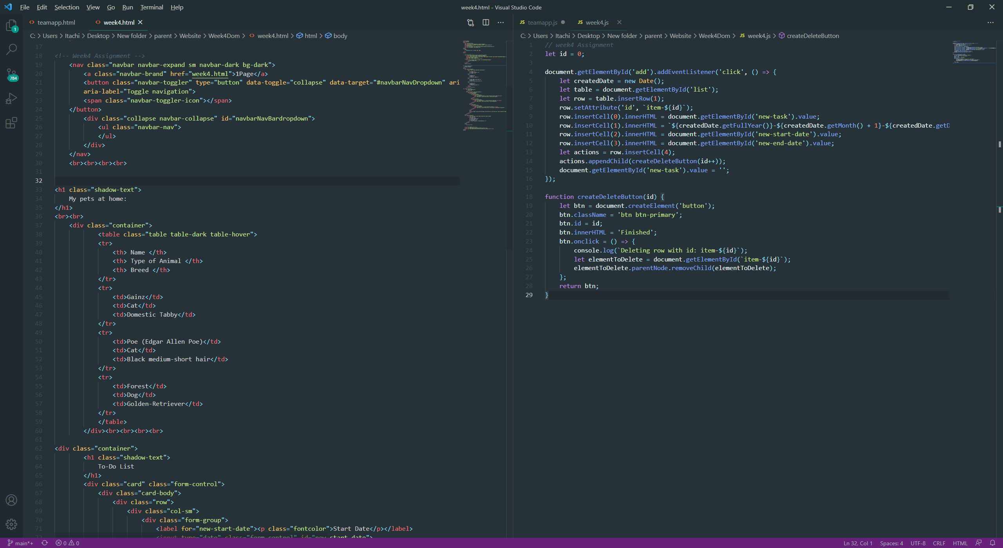

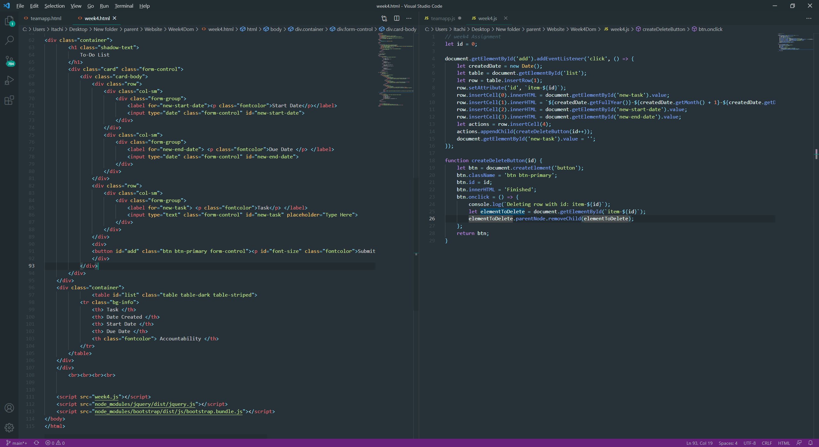

**Screenshots of Running Application:**

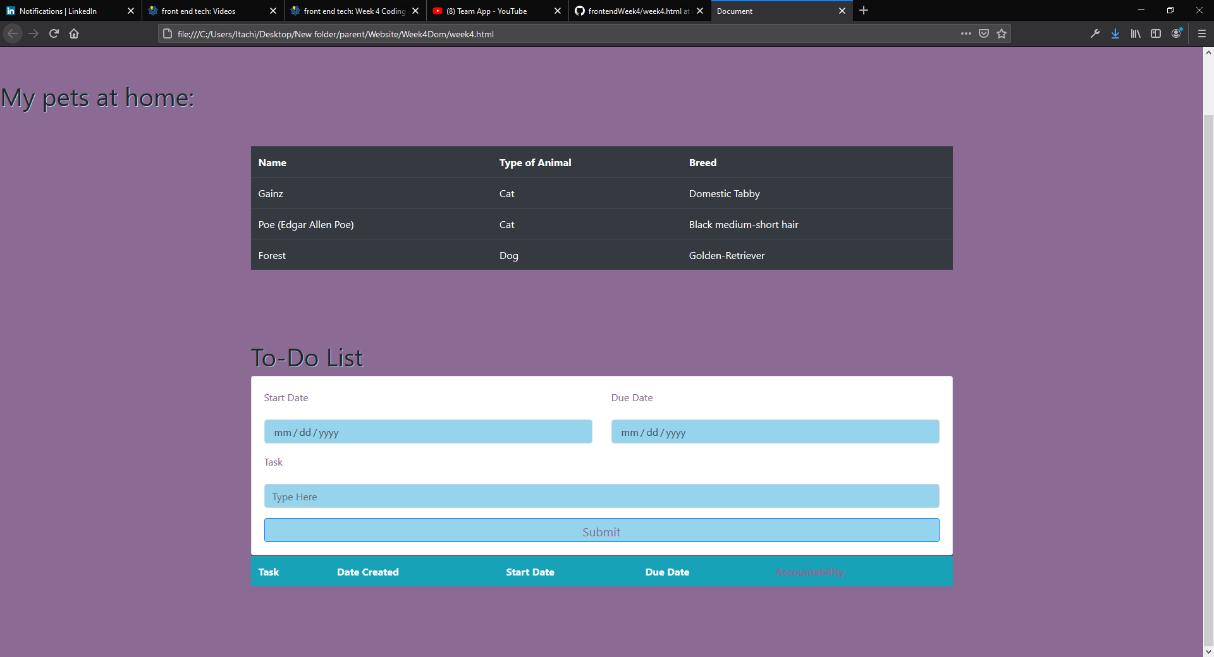

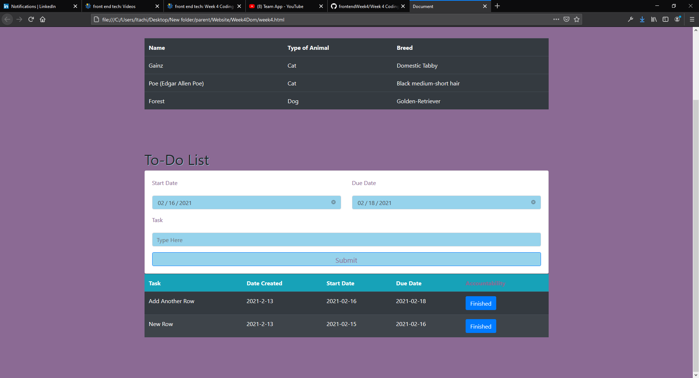

**URL to GitHub Repository:**

**https://github.com/AmarRed07/frontendWeek4.git**